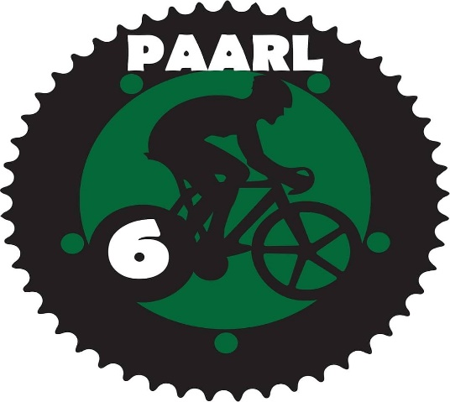ENTRY FORM

Date: 19 December 2020
Time: 11h00
VENUE: FAURE STADIUM – PAARL

- Team Omnium (6 Events)
- SPRINT CUP (3 Events)
2. Open 1-Day Omnium (5 Events/Category)

ENTRY FEE:
- Scholars – R60
- Open Junior/Elite Omnium (Men/Ladies) – R120
- Masters (Men/Ladies) – R120
- Team Competition/Team – R300

OPEN CATEGORIES

- Under 11/13/15/17
- Junior/Elite Ladies Open
- Junior/Elite Men Open
- Veterans Open

Cyclist Information

Name: ..........................................................................................................................

Surname: .....................................................................................................................

Province.......................................................................................................................

CSA License Number: ........................................................
(Compulsory)

Address: ......................................................................................................................

Category.......................................

Club/Team....................................................................................................................

Phone: .............................................................

Signature/Guardian............................................................

I enclose R.............. (To cover entry fee)

Banking Details : KG Bike Xpres cc
Bank : Standard Bank
Account nr : 2805 413 17
Branch code : 050210 (Paarl)
Reference : Cyclist name/Category
E-Mail Entry form to : bikexpres@yahoo.com

INDEMNITY FORM

I, ___________________________________________, hereby indemnify
PAARL 6 and organizers of Paarl 6 Event against any responsibility for any loss or damage that may occur to me or my belongings due to my partaking in the PAARL 6 Event.

Signed: ________________________________on the ________________________ (date) ________________________ (place)

Print Name: ______________________________

Or

I, ______________________________________, being the legal parent / guardian of

________________________________________, hereby grant my son / daughter permission to partake in the PAARL 6 Event. I also hereby indemnify PAARL 6 and the Organizers of Paarl 6 Event against any responsibility for any loss or damage that may occur to son/daughter or their belongings due to him / her partaking in the PAARL 6 Event.

Signed: ________________________________on the __________________________ (date)_____________________ (place)

Print Name: ______________________________

