PAARL 6
PAARL 6 herewith would like to thank each and everyone who contributed to the success of the 1st ever 6 in South Africa!

A special THANK YOU, in no specific order, to :
- Drakenstein Municipality
- Cape Winelands Sports Council
- Cape Winelands Cycling
- Cycling SA
- Western Cape Officials Association
- All Cyclists
- All Volunteers
- Sakhisizwe Ambulance Service
- Paarl AC Rotweiler Security
- All Musicians
- All Vendors
- The Daily Coffee
- Coca-Cola
- Peter Daniels (Commentator)
- Wayne Benjamin (Event Safety Officer)
- Rivers of Joy Full Gospel Congregation
PAARL 6
Hebrews 11:1 “Faith is the substance of things hoped for, the evidence of things not seen”
FAURE STADIUM – PAARL
18 – 23 DECEMBER 2018

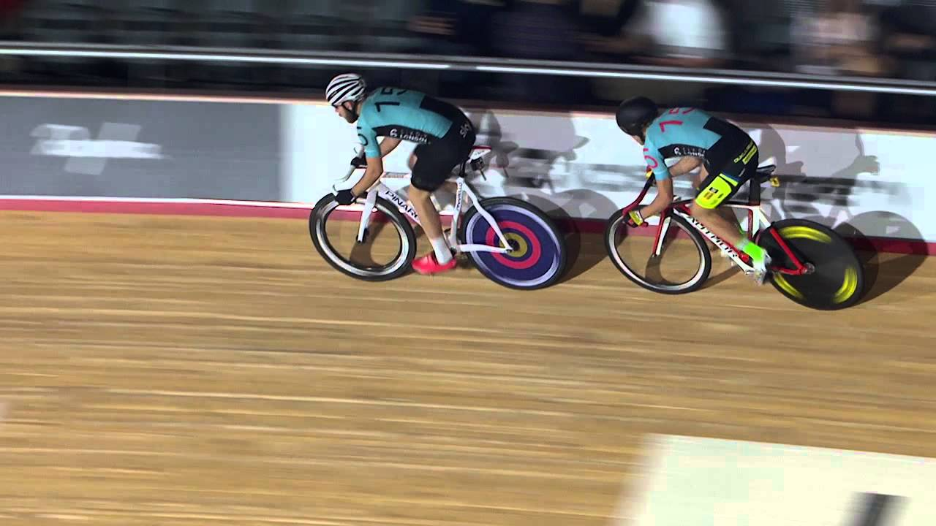

SUPPORTED BY
DRAKENSTEIN
MUNICIPALITY
KG Bike Xpres cc
PAARL 6
RULES OF THE GAME
- A 6 is a Track Cycling Race that lasts 6 days.
- The Overall Winner is the team which completes most laps.
- In the event of teams completing the same number of laps, the winner is the team with most points won in intermediate competitions.
- Teams compete in 6 races each night/day, and points are scores as follows per race:
- 1st – 20 Points 6th – 10 Points
- 2nd– 18 Points 7th – 8 Points
- 3rd – 16 Points 8th – 6 Points
- 4th – 14 Points 9th – 4 Points
- 5th – 12 Points 10th – 2 Points
- For every 100 Points a team scores, the team automatically scores 1 lap, thus the team will be on 1 Lap + 100 Points.

PROGRAM- DAY 1
TUESDAY, 18 DECEMBER 2018, 18H30
18H30 – 19H00 : OFFICIAL OPENING & TEAM PRESENTATION
19-19H30 : HOT SHOT PANTHERS MINSTRELS
ITEM # RACE
- Paarl 6 - 30 Lap Madison (Points every 10 Laps)
- Under 11 – 1500m
- Under 13 – 1500m
- Under 15 – 1500m
- Under 17 – 1500m
- Junior/Elite Ladies – 1500m
- Junior/Elite Men – 1500m
- Veteran Open – 1500m
- Paarl 6 – Super Sprint / Elimination
- Under 11/13 – 3km
- Under 15 – 3km
- Under 17 – 3km
- Junior/Elite Ladies – 3km
- Junior/Elite Men – 3km
- Veteran Open – 3km
- Paarl 6 – 20 Lap Points (Points Every 5 Laps)(Both Riders)
- 45 Minute – BOUNCY
- Paarl 6 – 500 Metre 2-Man TT
- Under 11 - 17 – 800m
- Junior/Elite Ladies – 5km
- Junior/Elite Men – 5km
- Veteran Open – 5km
- Paarl 6 – 10Km Scratch Race
- 15 Minute Interval / Prize Giving
- Paarl 6 – Longest Lap (Red Number)
PAARL 6
RULES OF THE GAME
- A 6 is a Track Cycling Race that lasts 6 days.
- The Overall Winner is the team which completes most laps.
- In the event of teams completing the same number of laps, the winner is the team with most points won in intermediate competitions.
- Teams compete in 6 races each night/day, and points are scores as follows per race:
- 1st – 20 Points 6th – 10 Points
- 2nd– 18 Points 7th – 8 Points
- 3rd – 16 Points 8th – 6 Points
- 4th – 14 Points 9th – 4 Points
- 5th – 12 Points 10th – 2 Pointsbnj
- For every 100 Points a team scores, the team automatically scores 1 lap, thus the team will be on 1 Lap + 100 Points.

PROGRAM – DAY 2
WEDNESDAY, 19 DECEMBER 2018, 18h30
ITEM # RACE
- HOT SHOT PANTHERS
- Paarl 6 – Longest Lap (Black Number)
- MC/COMEDY
- TheLeaks – 15 MINUTES
- Paarl 6 – 30 Lap Madison (Points every 10 Laps)
- MC / COMEDY
- BOUNCY – 30 MINUTES
- Paarl 6 – Super Sprint / Elimination (Both Riders/Team)

30 Minute Interval

- MC/COMEDY
- GRVP GVNG – 30 MINUTES
- Paarl 6 – 20 Lap Points Race (Points every 5 Laps)(Both Riders)
- MC/COMEDY
- HOT SHOT PANTHERS MINSTREL GROUP – INSTRUMENTAL 20 MINUTES
15 Minute Interval
- Paarl 6 – 500 Metre 2-Man TT
- MC/COMEDY
- BOUNCY – 30 MINUTES

15 Minute Interval

- Paarl 6 – 10 Km Scratch Race
- YoungstaCPT

PAARL 6
RULES OF THE GAME
- A 6 is a Track Cycling Race that lasts 6 days.
- The Overall Winner is the team which completes most laps.
- In the event of teams completing the same number of laps, the winner is the team with most points won in intermediate competitions.
- Teams compete in 6 races each night/day, and points are scores as follows per race:
- 1st – 20 Points 6th – 10 Points
- 2nd– 18 Points 7th – 8 Points
- 3rd – 16 Points 8th – 6 Points
- 4th – 14 Points 9th – 4 Points
- 5th – 12 Points 10th – 2 Points
- For every 100 Points a team scores, the team automatically scores 1 lap, thus the team will be on 1 Lap + 100 Points.

PROGRAM – DAY 3
THURSDAY, 20 DECEMBER 2018, 18H30
ITEM # RACE
- Paarl 6 – 10 Km Scratch Race
- Under 11 – 800 Metre Omnium
- Under 13 – 800 Metre Omnium
- Under 15 – 800 Metre Omnium
- Under 17 – 800 Metre Omnium
- Paarl 6 – Longest Lap (Red Number)
- Junior/Elite Ladies 800 Metre Omnium
- Junior/Elite Men 800 Metre Omnium
- Open Veteran – 800 Metre Omnium
- Under 11 – 6 Lap Points
- Under 13 - 8 Lap Points
- Under 15 – 10 Points
- Under 17 -12 Lap Points
- Paarl 6 – 40 Lap Madison (Points every 10 Laps)
- Junior/Elite Ladies 15 Lap Points
- Junior/Elite Men 20 Lap Points
- Open Veteran – 15 Lap Points
30-Minute Interval
- Paarl 6 – Super Sprint / Elimination (Both Riders)
- Under 11 – 1500 Metre
- Under 13 – 1500 Metre
- Under 15 – 1500 Metre
- Under 17 – 1500 Metre
- Junior/Elite Ladies – 1500 Metre
- DJ PLAY – 10 Minutes
- Paarl 6 – 20 Lap Points Race (Points every 5 Laps)(Both Riders)
15-Minute Interval
- Junior/Elite – 1500 Metre
- Veteran Open – 1500 Metre
- PAARL 6 – 500 Metre 2-Man TT

PAARL 6
RULES OF THE GAME
- A 6 is a Track Cycling Race that lasts 6 days.
- The Overall Winner is the team which completes most laps.
- In the event of teams completing the same number of laps, the winner is the team with most points won in intermediate competitions.
- Teams compete in 6 races each night/day, and points are scores as follows per race:
- 1st – 20 Points 6th – 10 Points
- 2nd– 18 Points 7th – 8 Points
- 3rd – 16 Points 8th – 6 Points
- 4th – 14 Points 9th – 4 Points
- 5th – 12 Points 10th – 2 Points
- For every 100 Points a team scores, the team automatically scores 1 lap, thus the team will be on 1 Lap + 100 Points.

PROGRAM – DAY 4
FRIDAY, 21 DECEMBER, 18H00
ITEM # RACE
- GERALD FOSTER
- Paarl 6 – 500 Metre 2-Man TT
- MC/COMEDY
- SETH McKINNON – BEAT BOX
- Paarl 6 – 10 Km Scratch Race
- MC/COMEDY
- TRVP GVNG – LIVE ENTERTAINMENT
- Paarl 6 – Longest Lap (Black Number)
- MC/COMEDY
- AL PETERSEN – LIVE ENTERTAINMENT
30-Minute Interval
- Paarl 6 – 40 Lap Madison (Points every 10 Laps)
- MC/COMEDY
- SETH McKINNON – BEAT BOX
- Paarl 6 – Super Sprint / Elimination (Both Riders)
- MC/COMEDY
- AL PETERSEN – LIVE ENTERTAINMENT
15 Minute Interval
- Paarl 6 – 25 Lap Points (Points every 5 Laps)(Both Riders)
- MC/COMEDY
- EARLY B – 45 Minutes

PAARL 6
RULES OF THE GAME
- A 6 is a Track Cycling Race that lasts 6 days.
- The Overall Winner is the team which completes most laps.
- In the event of teams completing the same number of laps, the winner is the team with most points won in intermediate competitions.
- Teams compete in 6 races each night/day, and points are scores as follows per race:
- 1st – 20 Points 6th – 10 Points
- 2nd– 18 Points 7th – 8 Points
- 3rd – 16 Points 8th – 6 Points
- 4th – 14 Points 9th – 4 Points
- 5th – 12 Points 10th – 2 Points
- For every 100 Points a team scores, the team automatically scores 1 lap, thus the team will be on 1 Lap + 100 Points.

PROGRAM – DAY 5
SATURDAY, 22 DECEMBER 2018, 14H00
ITEM # RACE
- Paarl 6 – 25 Lap Points (Points every 5 Laps) (Both Riders)
- Under 11 – 500M Time Trial
- Under 13 – 500M Time Trial
- Under 15 – 500M Time Trial
- Under 17 – 500M Time Trial
- Paarl 6 – 500 Metre 2-Man TT
- Junior/Elite Ladies – 200M Flying Start
- Junior/Elite Men – 200M Flying Start
- Veteran Open – 5Km
- DJ PLAY – 10 Minutes
- Paarl 6 – 10 Km Scratch Race
30 Minute Interval
- Under 11 – 3 laps
- Under 13 – 3 Laps
- Under 15 – 5 Laps
- Under 17 – 10 Laps
- Paarl 6 – Longest Lap (Red Number)
- DJ PLAY – 10 Minutes
- Junior/Elite Ladies – 10 Lap Points
- Junior/Elite Men – 15 Lap Points
- Veteran Open – 15 Lap Points
- Paarl 6 – 50 Lap Madison (Points every 10 Laps)
30 Minute Interval
- Under 11 – 6 Laps
- Under 13 – 6 Laps
- Under 15 – 10 Laps
- Under 17 – 15 Laps
- Junior/Elite Women – Elimination
- Junior/Elite Men – Elimination
- Veteran Open - ELimination
- Paarl 6 – Super Sprint / Elimination (Both Riders)

PAARL 6
RULES OF THE GAME
- A 6 is a Track Cycling Race that lasts 6 days.
- The Overall Winner is the team which completes most laps.
- In the event of teams completing the same number of laps, the winner is the team with most points won in intermediate competitions.
- Teams compete in 6 races each night/day, and points are scores as follows per race:
- 1st – 20 Points 6th – 10 Points
- 2nd– 18 Points 7th – 8 Points
- 3rd – 16 Points 8th – 6 Points
- 4th – 14 Points 9th – 4 Points
- 5th – 12 Points 10th – 2 Points
- For every 100 Points a team scores, the team automatically scores 1 lap, thus the team will be on 1 Lap + 100 Points.

PROGRAM – DAY 6
SUNDAY, 23 DECEMBER 2018, 11H00
ITEM # RACE
- Paarl 6 – Super Sprint / Elimination
- Under 11 – 800 Metre
- Under 13 – 800 Metre
- Under 15 – 800 Metre
- Under 17 – 800 Metre
- Junior & Elite Ladies – 1500 Metre
- Open Veteran – 1500 Metre
- Paarl 6 – 25 Lap Points (Points every 5 Laps) (Both Riders)
- Under 11 – 3 Laps
- Under 13 – 3 Laps
- Under 15 – 6 Laps
- Under 17 – 6 Laps
- Junior/Elite Ladies – Elimination
- Junior/Elite Men - Elimination
- Open Veteran – 21 Lap Points
- Paarl 6 – 500 Metre 2-Man TT
30 Minute Interval
- Paarl 6 – 10 Km Scratch Race
- Under 11 – 6 Laps
- Under 13 – 6 Laps
- Under 15 – 10 Laps
- Under 17 – 15 Laps
- Junior/Elite Ladies – 10 Laps
- Junior/Elite Men – 20 Lap Scratch Race
- Open Veteran – 20 Lap Scratch Race
- Paarl 6 – Longest Lap (Black Number)
30 Minute Interval / Prize Giving
- Paarl 6 – 80 Lap Madison (Points every 10 Laps)

OFFICIAL PRIZE GIVING

